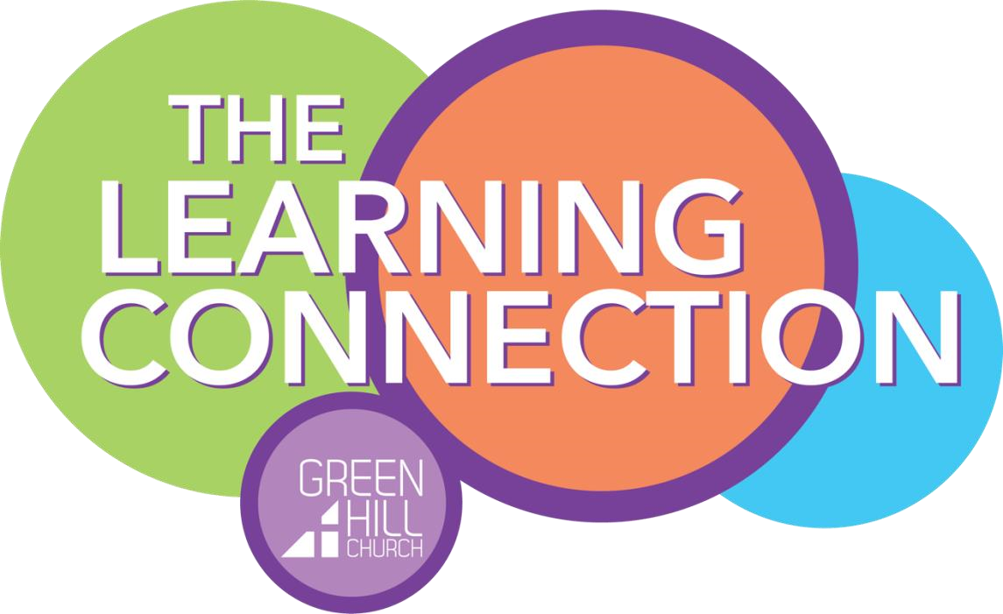

Parent Handbook
2024-25

13251 Lebanon Rd.
Mt. Juliet, TN 37122 greenhillchurch.com/tlc

Our Mission Statement: To serve the community and share the love of Jesus Christ by giving families a safe, caring, creative, and Christ-centered setting for kids

Dear Parents,

We are excited that your family has chosen to be a part of The Learning Connection, a ministry of Green Hill Church. We will be praying for your family and are excited to care for, love, and teach your child. We pray that your family will be blessed and ministered to through The Learning Connection.

We want you to enjoy your “day out” and be assured that your child is being well taken care of and loved by our staff. We feel that “children are a gift of the Lord” (Psalm 127:3), and we want to partner with you to teach the love of Jesus Christ.

Our program will provide a time of learning through activities, stories, music, nature, play, and a time of sharing and learning about God and His world. We value the time with your child as an opportunity to share the love and abilities God has given us,

Please feel free to contact me with any questions or concerns you might have at any time as well as comments or suggestions throughout the year. I will be happy to help and feel very blessed to serve the Lord and your family.

Blessings,
Cathy Postell
Director, The Learning Connection

Days and Hours of Operation:

The Learning Connection is open on Tuesdays and Thursdays from 9 a.m. to 2 p.m. We will follow the Wilson County Schools schedule relating to the closings for holidays and inclement weather.

Fees and Monthly Tuition:

A registration fee is required to hold a place for your child. This is a $75 fee per child ($200 maximum per family) and is non-refundable and non-transferable. To ensure a place for your child, early registration is recommended, as enrollment is based on order of registration and availability for each age group.

Tuition fees are due on the first Tuesday of the month. All accounts must be kept current. After the 10th of the month a $15 late charge will apply unless alternative arrangements have been made. All tuition payments should be made online at www.greenhillchurch.com/give.
Monthly Tuition: $165/month ($25 discount for second child)

There is a $35 charge for any returned check.

Absences:

No price adjustments will be made for absences. This includes times the school is closed for holidays or other occasions because tuition is based on the total number of school days.

Withdrawal:

After the school year beginning, we require at least a two-week written notice of withdrawal submitted to the Director. Parents/guardians continue to be responsible for payment for 14 days after the date of withdrawal notice whether the child is in attendance or not.

Safety: Arrival and Departure:

Drop off time is 9 a.m. Please do not bring your child earlier than 9 a.m. as teachers are preparing for the day. They will be unable to care for your child prior to class time. A parent/guardian should walk the child in, pick up a registration sticker, and walk the child to the door of the classroom. Parents are encouraged to leave their child at the classroom door and not enter the room.

Late fee:

Please be prompt in picking up your child from The Learning Connection. Any child remaining after 2 p.m. will be kept by The Learning Connection staff until the parent/guardian arrives. A late fee of $1 per minute will be charged every minute after 2:05 p.m. as our teachers are only being paid during the operating hours. This applies unless prior arrangements have been made with the director or teacher.

Custody:

The parent/guardian that enrolls the child in The Learning Connection and signs the agreement/release form has the right to say who may or may not pick up the child from The Learning Connection. There is a place on the enrollment form to list all persons allowed to pick up the child. The Learning Connection staff will verify names and valid driver’s license with the list when a new person is picking up. In addition, the person picking up should have the Chaperone label distributed at drop-off or a picture of it.

Any changes needing to be made concerning the release of your child must be given to the director in writing by the parent/guardian.

Parking:

Everyone must park in a parking space when dropping off or picking up their child. Please do not park under the canopy as this will be a safety hazard for children and their families as they walk to the parking lot.

Health:

Only healthy children will be accepted to The Learning Connection program. We are depending on you to maintain this policy. We cannot accept a child who has any of the following symptoms: Fever, diarrhea, vomiting, impetigo, chicken pox, persistent cough, head lice, colored nasal discharge, sore throat, pink eye or other contagious eye infection, undiagnosed or contagious skin rash or skin irritation, fifth disease or thrush, or any other symptoms of contagious diseases.

Your child is to be symptom-free for 24 hours prior to returning to PDO or be cleared by a doctor. If your child develops the above symptoms during the day, a parent will be contacted and asked to pick up the child immediately.

Parents will be notified when their child has been exposed to a communicable disease while attending The Learning Connection. Parents/guardians should likewise notify the Director immediately when their child has been exposed to a communicable disease.

Immunization:

Each child is required to have a current immunization record. We must have a copy of this record on file for your child. If immunizations are not current, they must be completed as soon as medically possible to remain enrolled.

Medications of any kind will not be administered by The Learning Connection staff.

Accidents:

In case of a serious accident or sudden emergency, the parent/guardian or the persons listed on the enrollment form will be notified immediately.

In case of minor injury while at The Learning Connection, there will be an accident report filled out for you to sign at the end of the day. This report will remain a part of your child’s file as long as he/she is enrolled in The Learning Connection.

Please notify us of any changes to emergency contact numbers.

A medical release form is included in the online registration packet.

Teaching Staff:

Our teachers are qualified caregivers and are committed to sharing Christ’s love with each child in our care. Every employee has passed a background check before employment. We strive to have one Lead Teacher and one Assistant Teacher or Teacher-in-Training in each class. Lead Teachers are professing Christians who are active in their local church and have a degree in Early Childhood Education or similar degree or experience. All teachers are committed to meet the daily needs of your child and make their day a happy and successful one.

Curriculum:

Children will engage in daily activities such as art, music, story time, Bible lesson, outside and indoor play, and varied age-appropriate preschool lessons such as colors, shapes, numbers/counting, alphabet, calendar days and months, weather, and group sharing time.

Note: We are not a Pre-school. Children will have no learning requirements. We are simply making the most of our time with the children in a relaxed, fun atmosphere.

Schedule:

Each class will maintain a guideline of daily activities, so the day runs smoothly. Your child will also grow to appreciate the routine.

A schedule will be posted in the classroom as well as a copy given to the parents. Times are approximate.

Lunch:

Children are to bring their own nutritious lunch. It should be finger foods or easy to eat items that do not need to be microwaved or refrigerated. Please label all lunch boxes and items in lunch boxes. Please send cups with a lid filled with a drink for lunch. Make sure cups are labeled.

Please note that Green Hill Church and The Learning Connection ministry is a nut-free zone. Do not send any food item containing nuts (i.e., peanut butter) to The Learning Connection.
Snacks:

Children will be given one snack during the day provided by The Learning Connection.

A parent/guardian must complete the Snack Release Form included in the online registration packet and state any allergies your child may have.

Nap/Rest Time:

Kindergarten type tri-fold mats, a small blanket, and a small pillow must be provided by parents. All items need to be able to fit in a small plastic tote. Please do not send expensive or sentimental items.

Children in the Three-Year-Old class and younger will be required to rest on their nap mats for the allotted time. They are not required to sleep. A quiet activity may be provided while others sleep. An appropriated G-rated movie or music may also be played during this time for older children.

Outside Play:

Weather permitting, the children will have outside play each day. We do not go outside if the weather is below 40 degrees or over 95 degrees. Please bring outerwear that is appropriate for the weather. If playing outside is not appropriate, children will have a special time to work on large motor skills.

Clothing:

Comfortable, washable, season appropriate play clothes are requested. Please dress your child in pants that are easy to pull up and down.

Tennis shoes or other shoes that die are preferred. Open toe shoes and those that are not secure to the foot are prohibited. This would include flip-flops and “Crocs”.

A change of clothing including underwear and socks will be needed in case of any accidents. The change of clothing will need to be sealed in a zip lock bag and stored in the child’s backpack. The zip lock bag and all clothing need to be clearly marked with the child’s name. The Learning Connection cannot be responsible for items that are not clearly labeled.

Personal Items:

Please keep your child’s personal toys at home. This helps so that they do not become lost or broken. If a security item is needed during nap time, please limit it to only one item. Please also label all items brought (nap blankets, pillow, school supplies, drink cups, etc.)

Potty Training:

Every child enrolled in the Three-year-old class and older must be potty-trained. Teachers will assist children as needed in their toileting needs when it pertains to buttons, zippers, and belts. For those currently being potty-trained, please share with the teacher special needs and requests.

All efforts will be made to aid in the potty-training process of younger children. We do ask that those that are working on this process wear pull-ups.

Class Parties and Birthdays:

Fall, Thanksgiving, Christmas, Valentine’s Day, Easter, Spring, and the End of the Year may be celebrated with a party. Teachers will be coordinating all the details for their class. Each child will need to contribute to the party’s meal. A signup sheet provided by the teacher will help coordinate the needed items. Parties will be held at lunchtime to ensure a nutritious meal rather than a snack of too many sweets.

If your child wishes to bring a treat to share with the class to celebrate his/her birthday, it is welcomed. Snack Time is the recommended time to celebrate. Children with summer birthdays are welcome to pick a day to celebrate in the year. Please arrange all details with the teacher.

Toys:

Because of the possessive feelings that children have toward their own toys and the discipline problems the toys may create, we ask that no toys be brought to The Learning Connection. EXCEPTION: If your teacher has a share day, your child may bring items that will enrich the classroom. We request that no toy weapons be brought to The Learning Connection.

Labeling Items:

All personal items need to be labeled with your child’s name. A lost and found box is in the hallway for misplaced or lost items.

Discipline:

Our main objective is to love your child as Jesus does. Our discipline will be positive and will encourage children to make good choices. Should a problem arise, corrective measures of a verbal reminder, restriction of privileges, or a brief time-out period will be used by the teacher. Should a child demonstrate a more aggressive or disruptive behavior the parent will be contacted, and The Learning Connection staff will work together with the parent to solve the problem.

Aggressive or disruptive behavior must not be overlooked because it sends a message to the other students in our care that this behavior is acceptable. A child needs to know that it is never “okay” to hurt another child or adult. If at any time The Learning Connection staff observes behavior that puts the child, another child, or the staff’s physical safety or well-being in jeopardy, The Learning Connection reserves the right to remove that child from the program.

If you have any concerns about your child, please feel free to talk with the teacher or the Director. We will refrain from talking about the child in their presence but will be happy to coordinate a time to discuss any issues.

Communication:

We strive to work with your family in partnership to love and teach your child. Please feel free to talk with your child’s teacher or the director.

Correspondence:

Emails from the director or teacher will be sent with upcoming events and important information. This is the primary means of communicating information.

Any hardcopy correspondence including class papers will be sent home in a folder provided for your child. Please open and read papers at the end of each PDO day. Then return the folder with the child each day.

Phone Calls:

For any phone communication concerning change in pick-up person or other personal information, your family’s selected passcode will be needed.

Separation Anxiety

During the toddler and preschool years, it is normal for children to show signs of separation anxiety. Typically beginning about nine months through age two, many children begin to exhibit signs of separation anxiety if left for any period of time with others or even another parent. This is common for the first couple of days a child attends PDO or when there is a change in routine. We assure you that we will care for, love, and reassure you child. You will be notified if your child does not calm down within 15 minutes. The following are tips given from therapists from Purdue University Anxiety Clinic when dealing with children who are experiencing separation anxiety:

- Stand your ground. Make sure your child knows they will be alright while you are gone. Try to settle them in the environment with the teacher before leaving, and then leave.
- Leave after offering reassurance and goodbyes. Lingering around or staying in the classroom will only prolong the situation. Hand your child over to the teacher and know he or she is in good hands.
- Compliment your child’s brave behavior.
- Talk to your child about what is going to happen beforehand. Spend some time talking to your child about what to expect, assuring that you will return.
- Establish a ritual. When leaving, try to do the same things every day such as a hug, kiss, and saying, “See you later, alligator!”
- Push the positives. Talk to your child about the fun things that happen at PDO such as story time, lunch with friends, snack time, art, etc.
- Make sure your child gets enough rest. If tired, your child may be cranky and even more clingy. On average, preschoolers require 12 hours of sleep.
- Know the crying will stop. Most of the crying stops within minutes of the parent leaving, so take comfort in that reality. Teachers are trained to engage your child in a fun activity or to encourage your him/her to begin playing with friends.
- Take perspective. Give your newly established routine two weeks. Most children will have adjusted in that amount of time and find they love playing with new friends, experiencing new activities, and interacting with their teacher.

Thank you for your time!

We look forward to spending the year with you and your child.

